Evaluating the Effects of Long-Lasting Insecticidal Nets (LLINs) Usage on Users and Non-users across Transmission Intensities

Background
Malaria control has made substantial gains over the past two decades, largely due to the scale-up of long-lasting insecticidal nets (LLINs) through mass distribution campaigns. Between 2000 and 2015, LLINs was found to have contributed 68% of the 663 million clinical malaria cases averted in endemic Africa, where LLIN is the dominant vector control intervention [1,2]. As a result, LLINs are widely regarded as among the most cost-effective public health interventions against malaria [3]. Their effectiveness arises from two complementary mechanisms: physical prevention of mosquito bites and the insecticidal action that kills or deters mosquitoes. Individuals sleeping under intact, treated nets benefit from direct personal protection, while populations benefit from indirect protection through reduced mosquito density, survival, and proportion of infectious mosquitoes. This community-level protection, sometimes referred to as indirect or community effect in previous studies, means that individuals who do not themselves use nets may nonetheless experience reduced malaria risk when net usage in the population is high [4–8].
Evidence for the community-level protection of LLINs has been demonstrated across multiple empirical [9–12] and modelling [13–15] studies, most notably from western Kenya, where reductions in malaria prevalence and child mortality were observed not only among net users but also among non-users living near households using nets [9]. Recognizing these indirect effects motivated a shift in malaria control policy from targeted net distribution toward universal coverage strategies [13]. By extending protection to all age groups, including adults who contribute to onward transmission, universal coverage aims to maximize both direct and population-level benefits [13]. A growing body of work indicates that indirect effects are heterogeneous and sensitive to local transmission dynamics, intervention coverage, and vector ecology. Recent re-analyses of cluster-randomized trials of malaria interventions such as chemoprevention and/or indoor residual spraying have demonstrated substantial spillover effects on incidence and prevalence among non-recipients but also highlighted that such effects vary with spatial scale, baseline transmission intensity, and intervention mix [12]. Systematic syntheses of these findings confirm that community effects contribute substantially to the overall impact of LLINs, particularly once coverage exceeds moderate levels [8].

Although these studies have shown that LLINs provide direct and community-level protection, important gaps remain in understanding how these benefits are distributed across users, non-users, and the overall population under different transmission intensities. Transmission intensity, often summarized by the entomological inoculation rate (EIR), is likely to be a critical determinant of community-level effects as it ranges from <1 to >1000 ib/person/year in sub-Saharan Africa. This indicates a wide heterogeneity between countries [3]. For instance, at high transmission intensity, persistent exposure to infectious bites may constrain the degree to which reductions in mosquito survival translate into substantial reductions in human infection prevalence, potentially leading to saturation of indirect effects even at high LLIN usage [4,16]. Empirical studies are often context-specific and do not allow for a clean deconvolution of the attribution of protection to direct and indirect mechanism, while existing modelling studies have rarely provided a unified comparison of direct, indirect, and overall LLIN protection across an array of transmission intensities. The magnitude and consistency of these effects remain heterogeneous across settings, and the extent to which increasing coverage yields additional benefits is not fully understood. Policy recommendations emphasize achieving high or universal LLIN coverage, often without explicitly considering how the additional benefits of increasing coverage vary across epidemiological contexts [17]. In resource-constrained settings, where funding limitations necessitate prioritization, it is critical to understand not only the total impact of LLINs but also how incremental increases in coverage translate into additional epidemiological benefit. In particular, it remains unclear whether increasing coverage beyond certain levels yields diminishing returns, and how such patterns differ across transmission intensities.
To our knowledge, the literature has been much stronger on documenting total direct and community effects than on asking where along the coverage gradient the next increase in coverage yields the greatest return or what coverage thresholds are required to achieve sufficiently high community-level protection. Moreover, the joint analysis of direct and indirect protection, incremental benefits, and policy-relevant thresholds within a unified modelling framework remains limited. In this study, we use a mathematical modelling approach to evaluate the impact of LLIN coverage across a range of transmission intensities. Specifically, we aim to: (i) quantify the direct (user) and indirect (non-user) protection conferred by LLINs across coverage levels; (ii) characterize the marginal (incremental) benefit of increasing LLIN coverage; and (iii) identify coverage thresholds required to achieve meaningful reductions in malaria prevalence among non-users. By integrating these perspectives, we provide a comprehensive assessment of how LLIN coverage translates into epidemiological impact and derive policy-relevant insights for optimizing intervention strategies under constrained resources.

Methods

Simulation model
OpenMalaria is an individual-based model used to simulate the dynamics of malaria transmission and epidemiology, and the impact of interventions on health and economic outcomes. It is a stochastic open-source platform initially designed for modeling malaria vaccines [18,19]. The model simulates various aspects, including the dynamics of malaria parasitemia during infection, the life cycle of mosquitoes, disease transmission between humans and mosquitoes, the development of anti-malaria immunity in human hosts [20], and the progression to illness and mortality. It captures heterogeneity in exposure, infection, and clinical outcomes across age groups. It has been used extensively to investigate multiple questions relating to disease dynamics or the use of existing and new interventions [19,21–23]. Detailed description of the model and its parameterization have been done elsewhere [21,24,25].

Simulation process
We used OpenMalaria (version 44.0) [23] to explore how changes in LLIN usage impact malaria burden across different transmission intensities. We distinguished between personal protection among LLIN users and community protection experienced by non-users due to reduced transmission. Simulations were set up using the OpenMalariaUtilities R package [26]. Starting from the characteristics of one region in Ghana in terms of demographic structure [27], seasonal transmission pattern (with a peak in October), dominant vector species composition (Anopheles gambiae s.s., An. arabiensis, and An. funestus), and a constant effective treatment of symptomatic cases [28], we performed simulations across a range of malaria transmission intensities. The entomological inoculation rate (EIR), defined as the number of infectious mosquito bites received per person per year, is a widely used measure of malaria transmission intensity, with empirical estimates in African endemic settings ranging from <1 to hundreds of infectious bites per person per year (ib/person/year) [29,30]. EIR was varied across a range of values to explore LLIN impact. We simulated the model for yearly EIR from 1 to 100, corresponding to $PfPR$ levels of [0.9%-47%]. We further categorized the EIR range into three epidemiological settings as low $PfPR$ [0.9%-10%] corresponding to EIR ≤2, moderate $PfPR$ [14%-35%] corresponding to EIR from 2.5–8, and high $PfPR$ [36%-47%] corresponding to EIR >8, and outcomes were averaged within each category. The categorization was done to reflect the WHO standard categories of transmission intensity [31]. This range allows assessment of the robustness of LLIN effects across realistic epidemiological settings relevant for most endemic contexts in sub-Saharan Africa.
Within OpenMalaria, bed nets act by modifying parameters of the mosquito feeding cycle model [32]. They reduce host availability, decrease the probability of successful blood feeding following host contact, and reduce the probability that a mosquito successfully finds a resting place after feeding [33]. We investigated user vs non-user protections of LLINs by tracking prevalence per cohort of individuals with respect to their net usage status. A cohort, in Openmalaria, refers to a sub-population which can be targeted with an intervention and monitored separately [23]. LLIN exposure was defined by usage rather than net ownership or treated versus untreated nets. At the individual level, LLIN usage represents the probability that a person sleeps under an LLIN on a given night. LLIN usage was varied from 0% to 80% at the population level, allowing users and non-users to coexist within the same simulated population such that 20% LLIN usage implies that 20% of the population sleep under a net after mass campaign distribution and the rest (80%) of the population become non-users. Importantly, one LLIN type, chlorfenapyr-pyrethroid net (Interceptor® G2) was considered in this study and the analysis focused on usage-driven protection rather than differences in net type or insecticidal decay. Given evidence that Interceptor® G2 retains relatively high mosquito mortality even after repeated washing and prolonged field use [34], surviving nets were assumed to maintain constant entomological efficacy throughout the simulation period. LLIN physical durability was represented by estimating functional survival half-life as 2.4 years using Interceptor® G2 usage data from [35]. The Interceptor® G2 bednet was parameterized [36] with entomological efficacy based on an experimental hut trial conducted in Cote D’Ivoire from May to July 2023 [37]. To obtain more realistic operational effectiveness of the nets we used estimates of ITN effectiveness quantified in a cascade as in [36]
The simulated population was stratified by LLIN usage status and three different age groups (0-5, 0-10 and the full age range, 0-100 years). At each level of LLIN usage, individuals were categorised as either LLIN users or LLIN non-users. This stratification enabled separate tracking of malaria prevalence among users and non-users while preserving shared exposure to the same transmission environment.
After a burnin period of # of years, the model reached equilibrium. At that point, we initiated effective treatment of malaria for symptomatic individuals starting in the year 2000. Starting in 2023, mass campaign distribution of LLIN was implemented in the years 2023, 2026 and 2029, assuming a 3-year net distribution cycle. In a population of 50’000, each scenario was simulated 10 times and ran up to the year 2031. To reproduce the rapid diagnostic test detection limit, parasite detection limit was set at 100 parasites per microliter in the model [38]. All LLIN effects were quantified relative to a counterfactual scenario in which LLIN usage was set to zero, to imply no LLIN usage across the simulated population. The prevalence observed among non-users in this counterfactual scenario was used as the reference prevalence for estimating LLIN effects among both users and non-users. This ensured that all effect estimates were anchored to a consistent, no LLIN transmission context.
Table 1: Model parameters and source
Parameter | Value | Source
Vector species proportion:  Anopheles gambiae s.s. An. Arabiensis  An. funestus | 0.6  0.1  0.3 | Assumed
Sporozoite rates:  Anopheles gambiae s.s. An. Arabiensis  An. funestus | 0.114  0.049  0.235 | [39]
Seasonality | Seasonal with a peak in October | Oti region - Ghana
Net type | Interceptor® G2 | [6]
Efficacy of nets | From experimental hut trial in Cote D’Ivoire | [37]
Net durability | 2.4-year half-life | [35]
Net use | Varied: 0% - 80% in increments of 10 | Assumed
Effective treatment | 40% constant yearly case management from 2000 to 2031 rescaled as effective treatement | [28]
Age structure | Ghana census / Worldpop?
Parasite detection limit | 100 parasites per microliter | [38]
Entomological inoculation rate | Varied from 1-100 | Assumed

Impact definitions and estimates
The primary outcome was malaria prevalence ($PfPR$), measured as the proportion of individuals in the simulated population with blood-stage parasite density above the detection limit of 100. Using prevalence as the outcome allowed direct comparison of infection burden across population groups. We defined two complementary measures of LLIN impact. We let $c$represent LLIN usage level and $x$ represent age group, so that ${PfPR}_{x, Users}(c)$ represent prevalence among LLIN users at usage level $c$ for age group $x$, ${PfPR}_{x,Non-users}(c)$ represent prevalence among non-users at usage level $c$ for age group $x$ and ${PfPR}_{x,counterfactual}$ represent the counterfactual prevalence defined as prevalence among non-users in simulations without LLIN usage (LLIN usage = 0). User protection was defined as the relative reduction in malaria prevalence among LLIN users compared to the counterfactual prevalence: ${User Protection}_{x}(c)=100*\frac{({PfPR}_{x,counterfactual}-{PfPR}_{x,Users}\left(c\right))}{{PfPR}_{x,counterfactual}}$. Non-user protection was defined as the relative reduction in malaria prevalence among LLIN non-users compared to the counterfactual prevalence, capturing benefits mediated through reduced community-level transmission: ${Non-user Protection}_{x}\left(c\right)=100*\frac{({PfPR}_{x,counterfactual}-{PfPR}_{x,Non-users})}{{PfPR}_{x,counterfactual}}$. Because LLIN usage in this analysis was set up to 80%, LLIN users and non-users coexisted in all simulated scenarios where LLINs were deployed. To understand further the benefit users and non-users achieve from LLIN usage, we calculated the number of users and non-users protected from infection as the product of the protection within each population group and the number of individuals within the group at a given usage level.

Sensitivity analysis
We assessed robustness by repeating the simulations under an alternative LLIN parameterization representing faster net attrition and reduced insecticidal efficacy, then compared key outcomes with the base-case parameterization.
All analyses were conducted in R (version 4.2.1 (2022-06-23)). Simulation outputs were aggregated by EIR category, LLIN usage, and population group. Results were summarised across transmission intensity levels to characterise how user and non-user effects vary with the counterfactual transmission.

Conceptual framework
A conceptual flow diagram was developed to summarise the modelling framework, illustrating the progression from model parameterisation and transmission intensity scenarios to LLIN usage, population stratification, counterfactual comparison, and estimation of user and non-user protection (Figure 1).
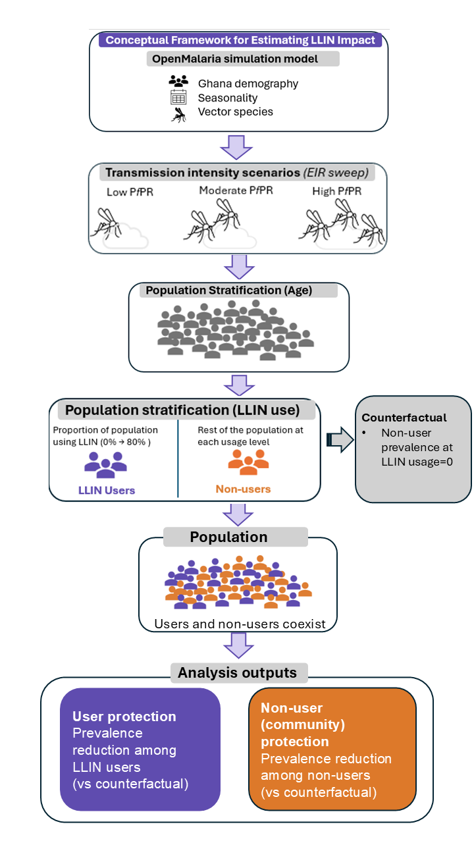
Figure 1: Conceptual framework for evaluating the effects of LLIN usage on users and non-users across transmission intensities. The OpenMalaria simulation model incorporates the demography, seasonality and vector species composition of one district in Ghana to simulate malaria transmission. Transmission intensity scenarios are defined through a range [1-100] of entomological inoculation rates (EIRs) categorized into low, moderate, and high epidemiological settings. For each transmission intensity, LLIN usage scenarios vary the proportion of the population using LLINs, generating distinct user and non-user groups. Individuals are stratified across age groups (0-5, 0-10 and 0–100 years), with users and non-users coexisting within the same simulated population. Outcomes include (i) protection among LLIN users, defined as the prevalence reduction among LLIN users relative to a counterfactual (LLIN usage = 0) and (ii) protection among non-users, defined as prevalence reduction among non-users relative to the same baseline.

Results
Prevalence across time, usage and transmission intensity
We simulated LLINs being used by 50% of the population from the year 2023 in a population of 50,000 individuals in a high transmission setting (${PfPR}_{0-100}$ 36% - 46%) and show in Figure 2A that all-age prevalence among LLIN users and non-users drop from 41% to 19% (interquartile range: [15–22]) and 22% (interquartile range: [18–25]) respectively, by 2024. Both population groups experience a decline in malaria prevalence due to the use of LLINs in the population, with net users experiencing lower prevalence across the years compared to non-users (Figure 2A). We did not observe a change in prevalence levels of the population groups over time, as prevalence levels were consistent within distribution cycles. The model was also used to project how malaria prevalence may differ among population groups for different levels of LLIN use (Figure 2B) and malaria endemicity (Figure 2C), using the average impact of LLINs over the nine years (Figure 2A) of LLIN use (three LLIN campaign distributions (2023-2031)) in the population. Malaria prevalence for both population groups declined as LLIN usage increased. At 50% usage (Figure 2A averaged at black dotted line in Figure 2B), the averaged prevalence declined from 41% to 20% (interquartile range: [15–24]) and 23% (interquartile range: [18–27]) among LLIN users and non-users respectively (Figure 2B). The reduction in prevalence for both population groups varied with entomological inoculation rate (EIR). Individuals who did not use nets still experience some level of reduction in prevalence across transmission intensities due to the presence of nets in the simulated population (Figure 2C).

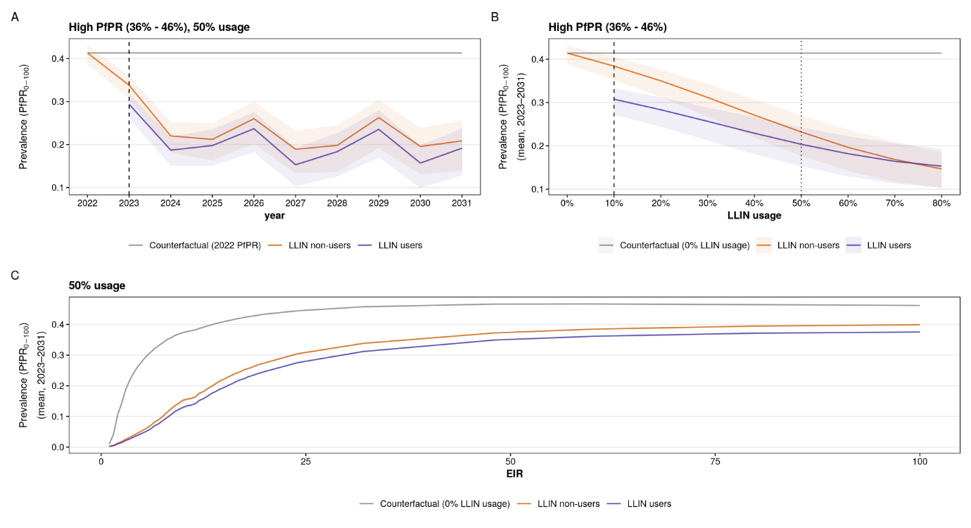
Figure 2: Impact of protection offered by LLIN on malaria prevalence among LLIN users and non-users. (A) All-age malaria prevalence over 10 years of simulation time, for high transmission setting (PfPR 36% - 46%) and 50% LLIN use (Dashed line indicates the start of LLIN deployment. In 2023, 50% of the population start to use nets. LLINs were deployed in 2023, 2026 and 2029, assuming a 3-year distribution cycle). (B) All-age prevalence averaged over nine years (three LLIN distribution cycles: 2023 – 2031) for high transmission setting (PfPR 36% - 46%. Black dashed line indicates lowest LLIN usage (10%) implemented in the model, whereas black dotted line indicates the averaged 50% LLIN usage simulation result shown in (A)). (C) All-age prevalence averaged over nine years (three LLIN distribution cycles: 2023 – 2031), at a usage level of 50%. In all panels, orange lines represent non LLIN users, purple line represent LLIN users and grey lines represent the counterfactual scenario. We show the mean and interquartile range for 10 seeds and the range of EIR values (EIR ranges from 1 to 100).
User and non-user protection across LLIN usage and transmission intensities
User and non-user protection were quantified as reductions in prevalence among the population groups, relative to the no-LLIN counterfactual (Figure 3). In low transmission setting (${ PfPR}_{0-100}$ [0.9%–10%]), LLIN usage resulted in very high reduction in prevalence among population groups, even at low to moderate usage levels. At 40% usage, prevalence reduction was already high, reaching 89% (interquartile range: [76.1–94.5]) among users and 83% (interquartile range: [70–93.2]) among non-users. Increasing usage from 50% to 80% resulted in a plateau of gains, with both groups approaching 91% reduction. In moderate transmission setting (${ PfPR}_{0-100}$ [13%-34%]), LLINs similarly produced high reductions in prevalence but with higher usage levels compared to low transmission setting. At 40% usage, prevalence reduction was 81.1% (interquartile range: [ 70.5–91]) among users, compared to 73.4% (interquartile range: [56.8–87.3]) among non-users. As usage increased from 60% to 80%, a plateau of gains was observed among both users and non-users, with both groups approaching 93% (interquartile range: [80.5–97]) reduction at 80% LLIN usage (Figure 3). In high transmission setting (${ PfPR}_{0-100}$ [36%-46%]), LLINs usage yielded more modest reductions in prevalence. At 40% usage, prevalence reduction was limited, with 45.1% (interquartile range: [31.6–55]) among users and 33.8 % (interquartile range: [16.5–43.8]) among non-users. Increasing coverage from 60% to 80% led to incremental improvements, reaching 65% (interquartile range: [31.4–76.8]) among both users and non-users at 80% usage. Despite these gains, there is no plateau observed in prevalence reduction between users and non-users across usage levels, indicating that community protection is weaker and accumulates more slowly in high transmission settings (Figure 3). Comparing relative prevalence reduction across transmission settings revealed that introducing LLIN use as well as further increasing usage led to consistent improvements in prevalence reduction for both population groups, although the magnitude of these gains varied by transmission intensity. Importantly, the difference in prevalence reduction between users and non-users across all transmission settings was minimal and narrowed (from 19.0% to 1% in low PfPR, 26.8 % to 0.5% in moderate PfPR and 17.6% to -0.6% in high PfPR) with increasing usage levels (10% to 80% usage), indicating strong community protection even at relatively low usage (Figure 3 and Table S1). Relative reduction in incidence was also observed in the simulations at a slightly higher magnitude (Figure S1). In low transmission setting (${ PfPR}_{0-100}$ [0.9%–10%]), incidence in all-age population groups was reduced by 87.3% (interquartile range: [70.7–92.2]) among users and 85.6% (interquartile range: [58.9–90.6]) among non-users at 40% LLIN usage. Increasing usage from 50% to 80% resulted in a plateau of gains, with both groups approaching 89% reduction. In moderate transmission setting (${ PfPR}_{0-100}$ [13%-34%]), incidence was reduced by 86.5% (interquartile range: [ 78.0–92.5]) among users, compared to 81.0% (interquartile range: [68.1–90.0]) among non-users, at 40% LLIN usage. As usage increased from 60% to 80%, a plateau of gains was observed among both users and non-users, with both groups approaching 94% (interquartile range: [80.5–97]) reduction at 80% LLIN usage (Figure S1). In high transmission setting (${ PfPR}_{0-100}$ [36%-46%]), LLINs usage yielded more modest reductions in incidence. At 40% usage, incidence was reduced by 57.9% (interquartile range: [42.0–67.5]) among users and 42.6 % (interquartile range: [30.4–56.0]) among non-users. Increasing coverage from 60% to 80% led to incremental gains as there was no plateau observed in this setting. LLIN effectiveness is highest in low transmission settings and progressively reduced in moderate and high transmission settings. Protection among non-users is strongest in low transmission settings. The rapid plateau of non-user protection indicates that community effect is highly efficient at low transmission, even at low-to-moderate usage levels. The relationship between LLIN usage and relative prevalence reduction was non-linear. Dependence on usage increases with transmission intensity. While low and moderate transmission settings achieve near-maximal impact at relatively moderate usage, high transmission setting requires substantially higher usage to achieve considerable protection among non-users (Figure 3).
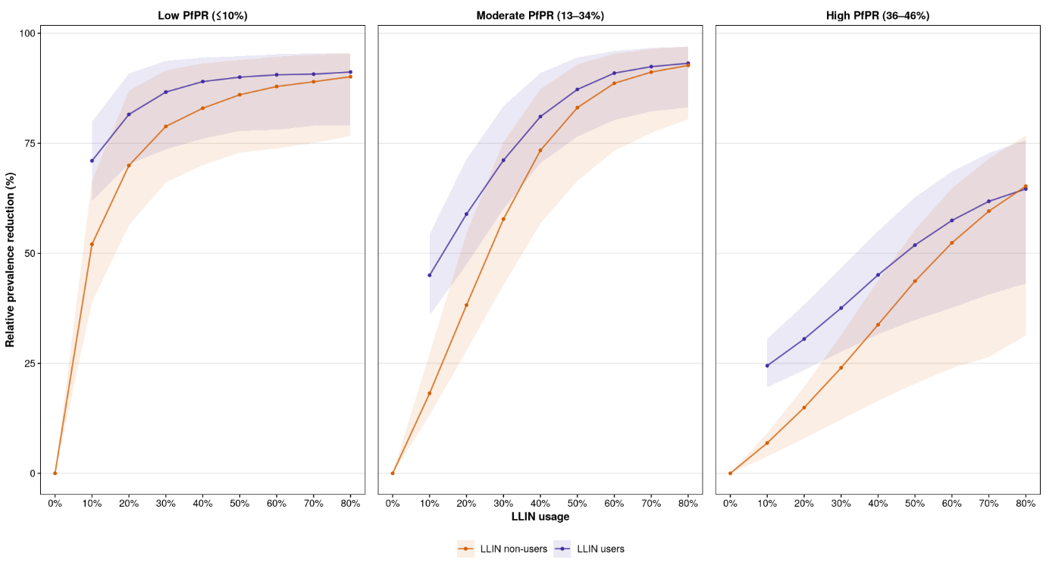
Figure 3: Relative reduction in malaria prevalence (protection) among LLIN users and non-users. The reduction in prevalence is calculated from a counterfactual scenario where nobody in the population is given a net. User and non-user protections are represented here for all LLIN usage levels. The protection for users is shown in purple and non-users in orange. Mean and interquartile range are shown for 10 seeds of each EIR level (EIR levels from 1 to 100) withing each PfPR setting.
Mean number of infections averted due to LLIN use
We also quantified the total number of infections averted in the simulated population due to LLIN use at each usage level and compared this with the counterfactual scenario where there is no LLIN usage (Figure 4). We found that the total number of infections averted increased with increasing usage in all transmission settings, although the magnitude of the gains differed (Figure 4A). In low PfPR setting, the number of infections averted increased from 1329.3 (interquartile range: [243.9 – 2785.7]) at 10% LLIN usage, representing 51% of the infections expected under the counterfactual scenario, to 1851.9 (interquartile range: [398.2 – 4364.7]) at 80% LLIN usage, representing 71% of the infections expected under the counterfactual scenario. A plateau was observed beginning at 40% usage, beyond which increasing LLIN usage did not show substantial additional gains. In moderate PfPR setting, the number of infections averted increased from 3117.7 (interquartile range: [2779.6 – 3467.6]) at 10% LLIN usage, representing 22% of the infections expected under the counterfactual scenario to 12597.3 (interquartile range: [10411.0 – 13711.5]) at 80% LLIN usage, representing 92% of the infections expected under the counterfactual scenario. A plateau was also observed in moderate settings but at a higher usage level beginning at 60% usage, beyond which increasing LLIN usage did not show substantial additional gains. In high PfPR setting, no plateau was observed as gains continued to increase with increasing LLIN usage even up to 80%. The number of infections averted increased from 1841.3 (interquartile range: [1647.6 – 2158.7]) at 10% LLIN usage, representing % of the infections expected under the counterfactual scenario to 13088.5 (interquartile range: [11979.8 – 14152.5]) at 80% LLIN usage, representing % of the infections expected under the counterfactual scenario (Figure 4A and Table S2). Across all settings, the total number of infections averted remained below the mean number of infections expected under the counterfactual scenario, indicating that residual malaria transmission persisted even at high LLIN usage, especially in high transmission setting where a wider gap between the mean number of infections at 0% LLIN usage (grey line) and the number of infections averted due to LLIN use (black bars) was observed (Figure 4A). Decomposition of the total number of infections averted by usage status revealed the number of infections averted among users and non-users (Figure 4B). In low transmission setting, the infections averted among non-users decreased rapidly from 88% infections averted at 10% LLIN usage to 20% at 80% LLIN usage, contributing as much to the total impact as the users at 50% LLIN usage (Figure 4B and Table S2). In moderate transmission setting, infections averted among non-users decreased from 80% infections averted at 10% usage to 20% at 80% LLIN usage, contributing as much to the total impact as the users at 50% LLIN usage (Figure 4B and Table S2). In high transmission setting, infections averted among non-users decreased from 72% infections averted at 10% usage to 20% at 80% LLIN usage. LLIN users and non-users did not contribute as much to the total infections averted at any LLIN usage level in high PfPR setting (Figure 4B and Table S2). Although the impact of increasing LLIN usage was observed in both user and non-user groups across all transmission settings, the highest impact was observed in low transmission settings, with this impact declining with increasing transmission intensity.

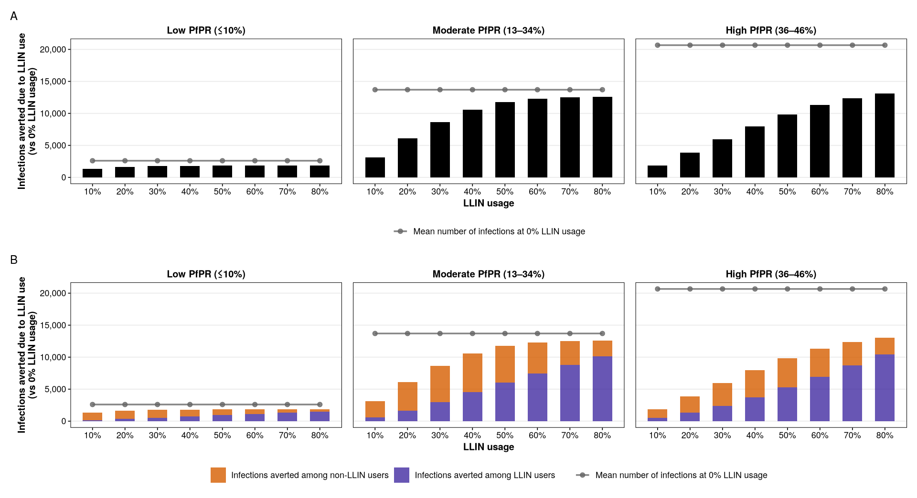
Figure 4: Number of infections averted due to LLIN use. We quantified the mean yearly number of infections averted in the simulated population at each usage level. (A) shows the total number of infections averted in the population at each usage level, relative to the counterfactual. Black bars represent the total number of infections averted. Grey line shows the expected number of infections at 0% LLIN usage (the counterfactual scenario where there is no LLIN usage in the population) in the simulated population. (B) shows the contribution of both LLIN users and non-users to the overall impact in (A). Orange bars represent the number of infections averted among non-users whereas purple bars represent the number of infections averted among LLIN users. Grey line shows the expected number of infections at 0% LLIN usage (he counterfactual scenario where there is no LLIN usage in the population) in the simulated population.

Discussion
Notes from Lukole et al. 2025 - community benefits of 3 LLINs
- minimum coverage levels for community protection in pyrethroid-only nets 15 - 85% - Lines et al. [15]
- Consistent with this, a study conducted in Kenya [32] concluded that at least 35% community coverage of nets is required to protect people sleeping without nets
- Lindblade et al. [33] found that community net usage (> 82%) protected both users and non-users equally.
models have also been used to estimate the threshold of usage necessary to elicit community protection:
- Killeen et al. [7] modelled that coverage of 35–65% would be needed to
- achieve community-wide benefits.
- Another model [23] suggested that as soon as one person uses an LLIN, there is a small indirect impact on non-users (even if marginal) compared to a hypothetical scenario where nobody is using net – our results fall within their range
indirect protection is achieved early and diminishes or plateaus as usage increases hence can be achieved even with moderate coverage
“when a net is very effective, as observed for chlorfenapyr LLINs, both users and
non-users are protected even at moderate to low levels of community coverage.” - for IG2 in our case
- What we did
Long-lasting insecticidal nets (LLINs) offer protection to both users and non-users in a population, but how this protection emerge, scale and saturate across transmission intensity and effective LLIN usage remains incompletely evaluated as evidence from randomized controlled trials are usually context specific. In this modelling study, we used an agent-based model of malaria transmission [23] to quantify how the protection offered by LLINs varies across transmission intensities and effective LLIN usage. This results in important insights for resource allocation in a resource-constrained context.
- What we found
Our results showed that both LLIN users and non-users benefit from a reduction in prevalence and incidence once LLINs are introduced in the population or when effective usage is increased even though increasing LLIN usage to higher levels beyond 40 – 60% did not result in incremental gains in some transmission settings. A plateau in gains was observed in low and moderate transmission settings. There was a non-linear relationship between the impact of LLIN usage and the relative reduction in prevalence. Across all transmission settings, a reduction in prevalence and incidence was observed with the highest reduction occurring in low transmission settings. The reduction in incidence was of a slightly higher magnitude compared to the reduction in prevalence, especially in moderate and high transmission settings. Residual transmission persisted even at high LLIN usage levels.
- What do the results mean? – interpretation
Plateau in gains / non-linear relationship – why
The non-linear relationship between LLIN usage and infections averted may be because in low and moderate PfPR settings indicating the diminishing of gains at higher coverage may likely reflect the establishment of substantial community protection, whereby much of the preventable transmission has already been interrupted and each additional increase in LLIN usage averts progressively fewer infections. It should also be noted that at high LLIN usage, fewer non-users are present in the population to benefit from the impact of the interventions.
The reduction in incidence was of a slightly higher magnitude compared to the reduction in prevalence, especially in moderate and high transmission settings – why
Residual transmission persists at high usage – why?
The persistence of residual transmission even at high LLIN usage levels emphasizes that LLINs alone are not sufficient, hence the need for complementary interventions especially in high transmission settings. For instance, in high transmission settings, high LLIN usage together with intervention combinations would be required to achieve similar targets reached in low transmission settings [40].
Similar magnitude of infections averted was observed in moderate and high transmission settings – why
The relatively small difference in the total number of infections averted between moderate and high transmission settings may reflect the persistence of residual malaria transmission in high-transmission settings. Although LLINs substantially reduce exposure, ongoing transmission maintained by high vector densities and behavioural adaptations such as outdoor limits the incremental gains achievable with increasing coverage, consistent with previous modelling and empirical studies. In addition, repeated exposure in high-transmission settings leads to the accumulation of naturally acquired immunity, which alters host susceptibility and infection dynamics, potentially reducing the differences in intervention impact in those two transmission settings.
- Alignment with previous studies
Our findings reinforce existing evidence that LLINs offer protection for both users and individuals who do not use nets. Hawley et al. found that households without treated nets benefited when located near households with treated nets in western Kenya, supporting the existence of a community effect [9]. More recently, Unwin and colleagues used a transmission model to quantify the direct and indirect protection from insecticide-treated nets and showed that both users and non-users can benefit from community protection [15]. Simulation results indicated that the magnitude of community protection varies substantially across transmission settings. This dependence on transmission intensity we observed is also consistent with previous studies. In low and moderate transmission settings, protection among non-users increases rapidly with usage and approaches the level of protection among users at moderate usage levels, indicating that moderate usage levels are enough for both users and non-users to benefit similarly. In contrast, in high transmission settings, protection among non-users remains limited even at high usage, highlighting the persistence of residual transmission despite widespread LLIN use. This is consistent with programmatic evidence from Uganda showing that universal LLIN distribution produced only modest improvements in some higher-burden settings, and that additional IRS was needed to achieve larger gains where transmission remained intense [41]. In addition, Griffin et al. showed that high LLIN coverage could reduce prevalence to very low levels in low-transmission settings, while substantially higher transmission settings were less responsive to LLIN scale-up alone [40]. Both relative reduction in prevalence and the analysis of infections averted revealed a plateau in gains associated with increasing LLIN usage in some settings. In low and moderate transmission settings, prevalence reduction and infections averted increased rapidly at low-to-moderate usage levels, but the incremental gains diminished at higher usage levels, indicating a plateau in intervention impact. This likely reflects the establishment of substantial community protection, whereby much of the preventable transmission has already been interrupted and each additional increase in LLIN usage averts progressively fewer infections. In high transmission settings, however, relative reduction in prevalence and infections averted continued to grow with increasing LLIN usage, with no clear evidence of saturation within the range examined. Ongoing residual transmission maintained opportunities for further reductions in infections as coverage increased. While WHO recommends universal coverage that covers everyone one at risk of malaria [17], and some prior work highlighting the importance of high coverage [15,42], our results suggest that the efficiency of additional usage is context-dependent, and that increasing effective usage beyond certain levels may yield limited additional benefit in some transmission settings. The results here therefore support the importance of high coverage for high transmission settings but also support more broadly the finding that moderate coverage levels are enough to produce equitable community effects of insecticide treated nets [13], as seen here in low and moderate transmission settings. In high-transmission settings, LLINs continue to avert many infections because the baseline burden is high. However, residual transmission remains substantial despite increasing LLIN usage, limiting the additional reductions achievable with LLINs alone. At the same time, naturally acquired immunity in highly exposed populations means that reductions in infection do not necessarily translate proportionally into reductions in disease burden

Earlier modelling by Killeen et al. did argue for rational all-age coverage targets and highlighted the importance of community-level protection, which is broadly consistent with our threshold-oriented framing, but it did not estimate the same incremental-benefit metric used here [13].
- Policy implications
These findings have direct implications for malaria control strategies, particularly in the context of constrained resources. In low transmission settings, where indirect protection is strong and marginal gains decline rapidly, achieving moderate usage may be sufficient to generate substantial community-wide benefits. Beyond this level, additional increases in usage yield limited incremental benefits. In such settings, resources may be more effectively allocated in alternative ways such as maintaining usage by improving LLIN access between mass LLIN distribution campaigns through continuous distribution channels to bridge usage gaps [17], organizing social and behavioural change campaigns or investing in complementary interventions or distribution channels. In moderate transmission settings, our results indicate the existence of an optimal usage range, within which incremental benefits are maximized. Targeting this range may provide the highest return on investment. In high transmission settings, where indirect effects remain limited and incremental benefits continue to grow with usage, maximizing LLIN usage remains essential. These findings support recommendations for high coverage in high-burden settings but also highlight the importance of context-specific strategies rather than uniform coverage targets [17]. Since community protection depends strongly on the killing effect of nets, the distribution of net products that kill mosquitoes most effectively should be prioritized by policy makers to ensure these usage thresholds still confer substantial protection to non-users.
- limitations and strengths
A key strength of this study is the integrated analysis of direct, indirect, and incremental effects of LLIN coverage within a unified modelling framework, allowing for a comprehensive assessment of both total and incremental impact. By explicitly quantifying usage thresholds, we provide outputs that are directly relevant to policy and decision-making. However, several limitations should be noted. The study relies on a model of malaria transmission, which is only a simplification of reality, and may not fully capture all sources of heterogeneity present in real-world contexts, including variations in human behaviour, spatial heterogeneity, durability of nets, and intervention adherence. We could not account for spatial heterogeneity in the model and hence assume that non-users are in close enough proximity to LLIN users to benefit from reduced transmission. The analysis focuses on prevalence reduction and does not directly incorporate other outcomes such as incidence, severe disease, or cost-effectiveness, which are also critical for decision-making. The effect of the spread of pyrethroid resistance across sub-Saharan Africa [43] was not considered in this study which could alter the LLIN effects seen here. Previous studies suggest that the higher infection rates observed among non-users compared to users in recent data may reflect diminished community protection, potentially driven by pyrethroid resistance [44]. However, a modelling study by Unwin et al. found very little difference between users and non-users in the presence of insecticide resistance but also caution that their estimates may be highly variable [15]. Furthermore, it has been demonstrated that the benefits derived from LLINs deployed against vector populations that are already pyrethroid-resistant depend on killing more mosquitoes than on protecting more humans [42]. Lukole and colleagues also found that chlorfenapyr nets still provide protection for non-users at low coverage levels in a moderate to high transmission setting with resistance to pyrethroids [10].
This means that in areas with resistant mosquitoes to pyrethroids, switching to next-generation nets can still preserve community protection even in resistant settings at the usage thresholds identified here. Despite these limitations, the model provides useful insights that may otherwise be impossible to ascertain in empirical studies. Another limitation is that results here do not consider decay in insecticidal efficacy within distribution cycles and may represent the maximum biological effect of the chlofenapyr net, overestimating community protection. However, our sensitivity analysis (cite supplementary) performed representing faster net attrition and reduced insecticidal efficacy suggests that general conclusions about community protection are preserved.
Overall, our results support a context-specific interpretation of LLIN scale-up. Previous literature clearly supports the existence of direct and community protection from insecticide-treated nets and shows that intervention impact depends on transmission intensity. Building on that foundation, our study suggests that the epidemiological return to each additional increase in LLIN coverage is itself transmission-dependent, and that this can be translated into practical coverage thresholds for decision-making.

References

